**Practical 3**

**Programming Activities and fragments**

Activity Life Cycle, Activity methods, Multiple Activities, Life Cycle of fragments and multiple fragments.

# Activity Life Cycle

## The various methods to be created are onStart(), onRestart(), onStop(), onResume(),onDestroy() and onPause() as shown in the figure.

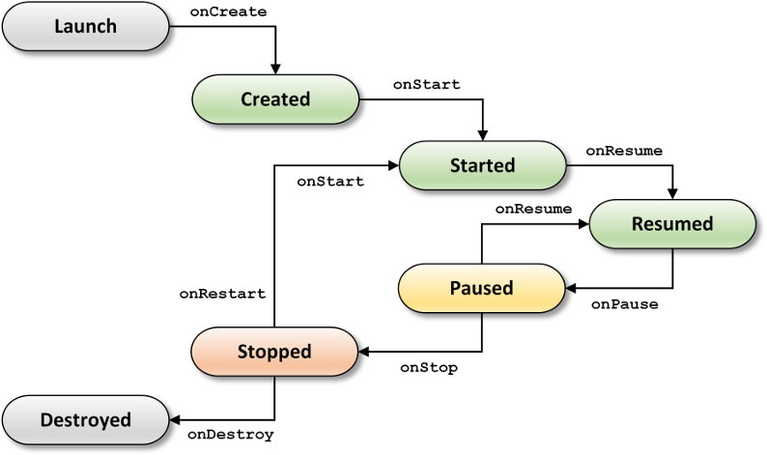

Create a new project and go to, **MainActivity.java**

### **package** MaharashtraCollege.example.profshahidansari;

**import** androidx.appcompat.app.AppCompatActivity;

**import** android.os.Bundle;

**import** android.util.Log;

**public class** MainActivity **extends** AppCompatActivity {

String **tag**= **"Android Lifecycle Demonstration"**; @Override

**protected void** onCreate(Bundle savedInstanceState) { **super**.onCreate(savedInstanceState); setContentView(R.layout.***activity_main***); Log.*d*(**tag**,**"In the onCreate() event"**);

### }

**public void** onStart()

### {

**super**.onStart();

Log.*d*(**tag**,**"In the onStart() event"**);

### }

**public void** onRestart()

{ **super**.onRestart();

Log.*d*(**tag**,**"In the onRestart() event"**);

### }

**public void** onPause()

### {

**super**.onPause();

Log.*d*(**tag**,**"In the onPause() event"**);

### }

**public void** onStop()

### {

**super**.onStop();

Log.*d*(**tag**,**"In the onStop() event"**);

### }

**public void** onDestroy()

### {

**super**.onDestroy();

Log.*d*(**tag**,**"In the onDestroy() event"**);

### }

}

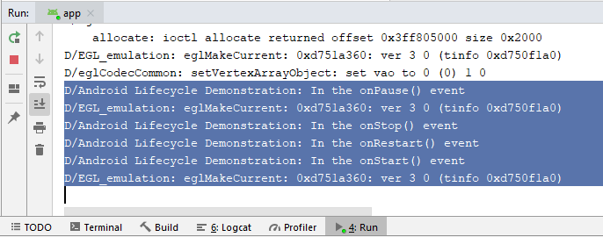

Output

See the Output in Run tab